Wind Turbine

A wind turbine uses the wind to make electrical energy. The wind turning the blades is mechanical energy. The turbine transforms the mechanical energy into electrical energy.

Experiment: Light the string of lights with the wind turbine.

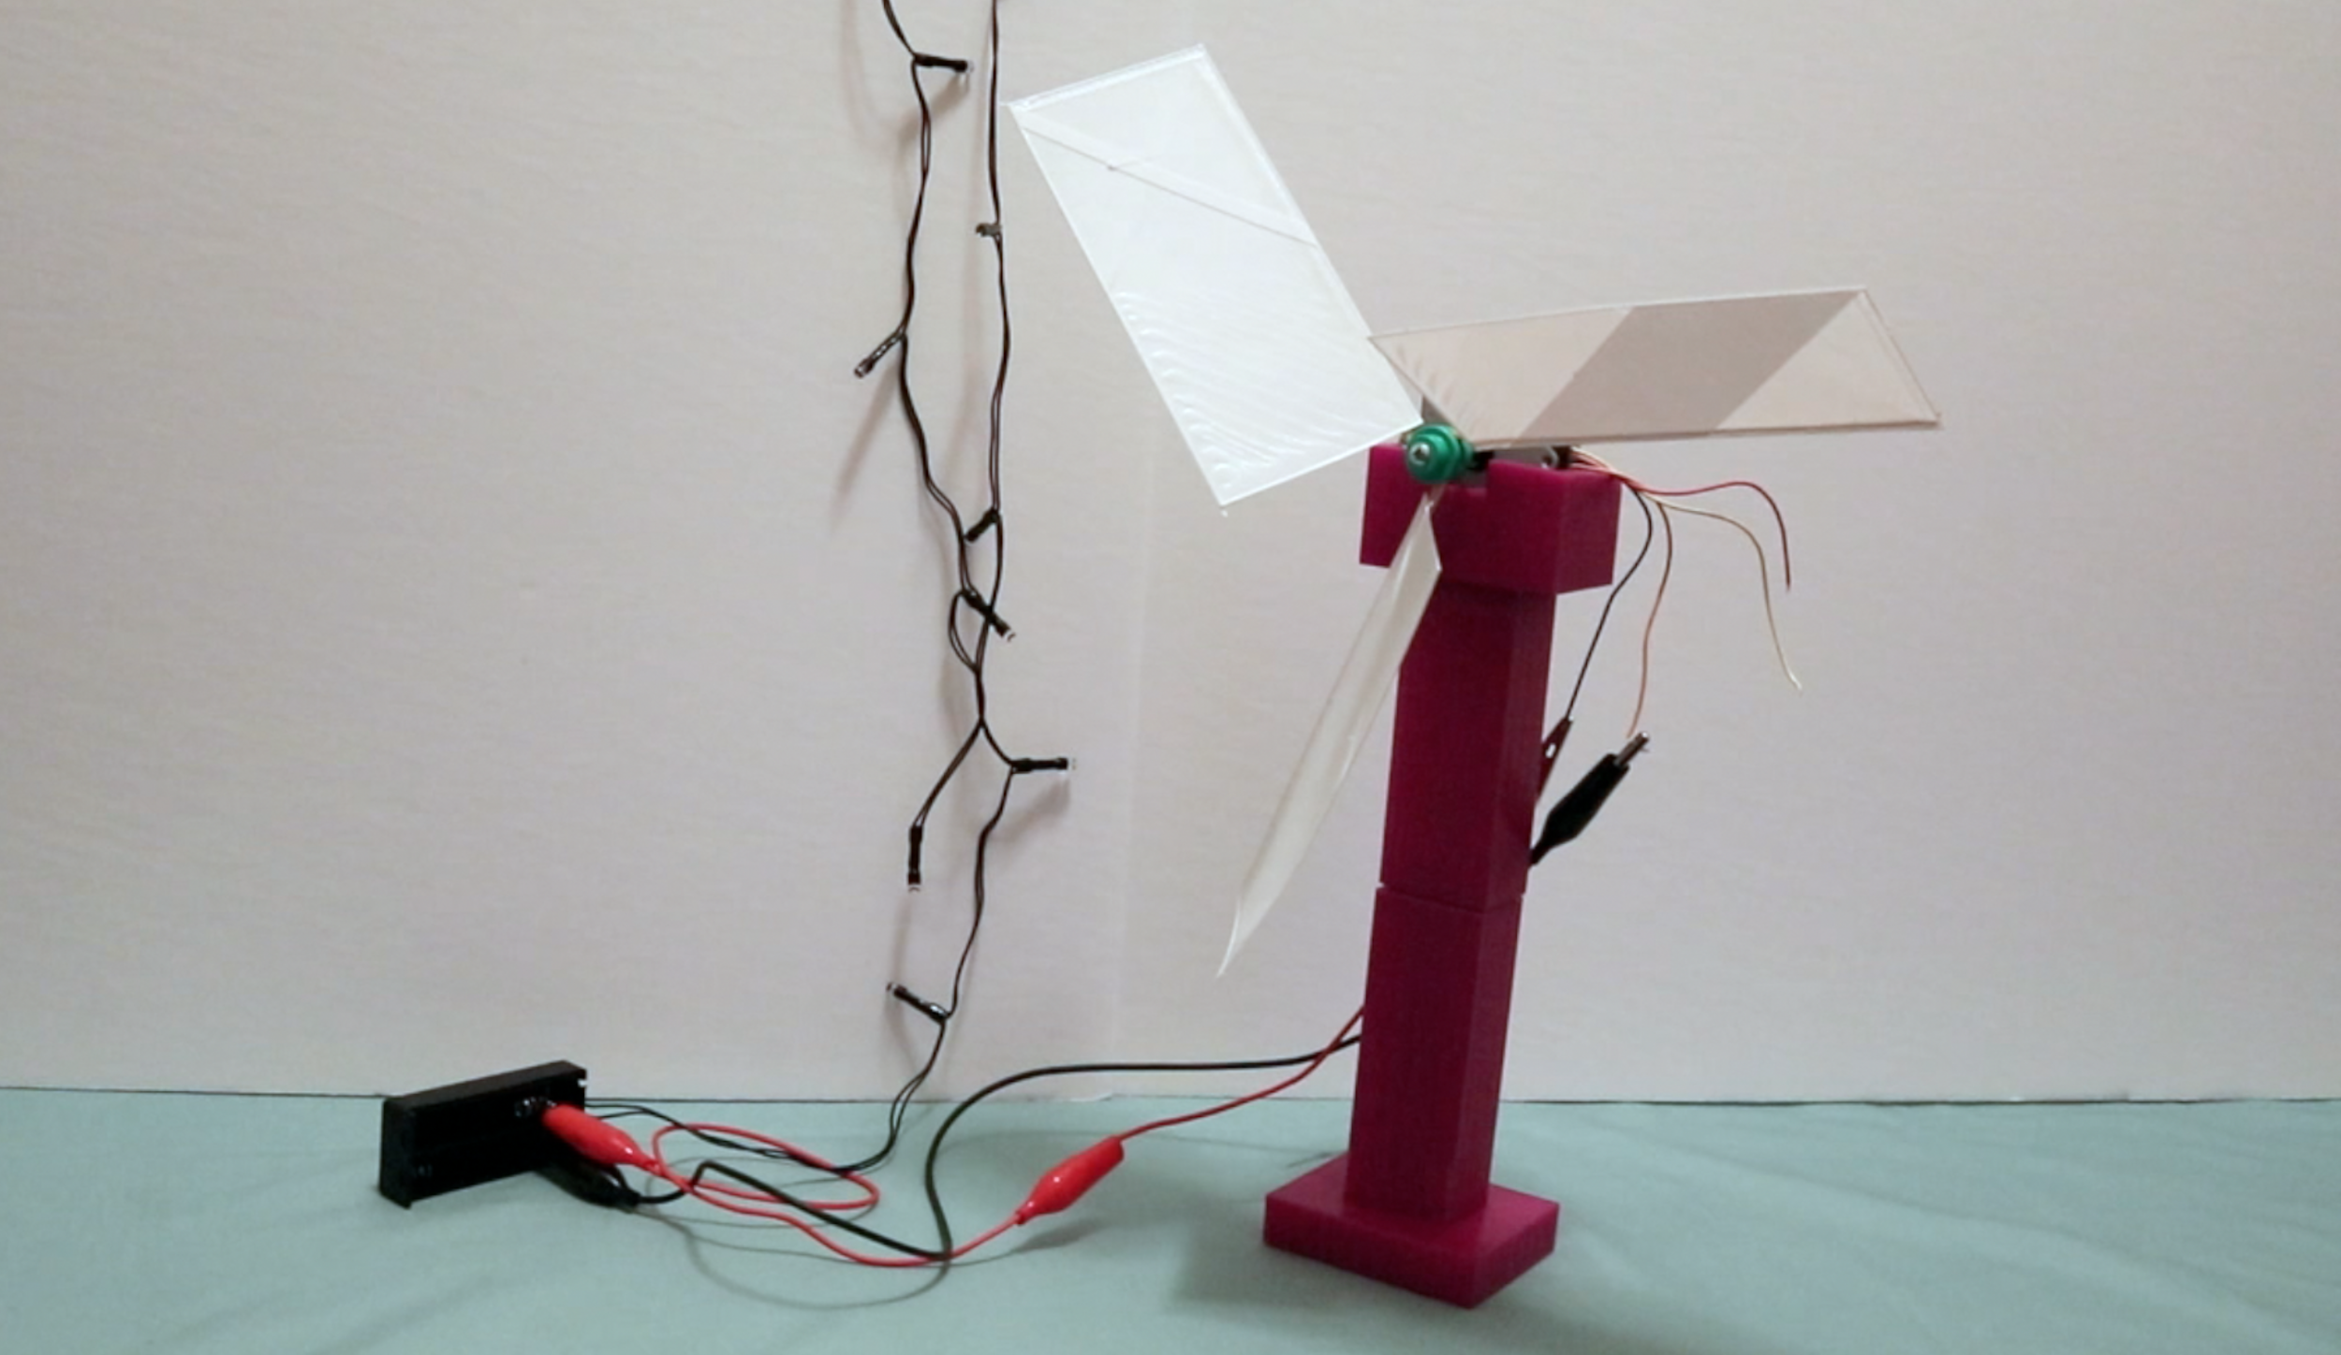

Challenge: What shape/design for the blades is the best? Draw what you think would be the best design and write a sentence why!

