Windmill

A windmill transforms wind energy into mechanical energy to lift the bucket.

Experiment: How many washers can the windmill lift?

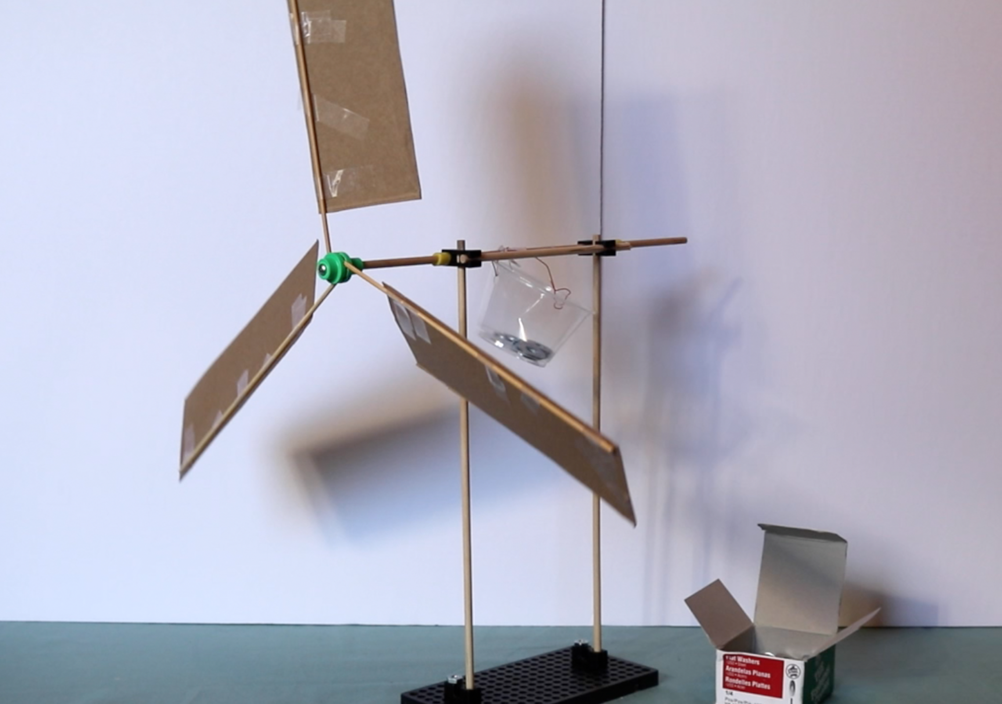

Challenge: What shape/design for the blades is the best? Create a windmill blades using cardboard or plastic!

