Hand Crank Generator

The hand crank generator turns mechanical energy into electrical energy.

Inside the hand crank generator there is a magnet and a copper coil. When you turn the handle, you cause the copper coil to spin around inside the magnet. This creates electrical energy.

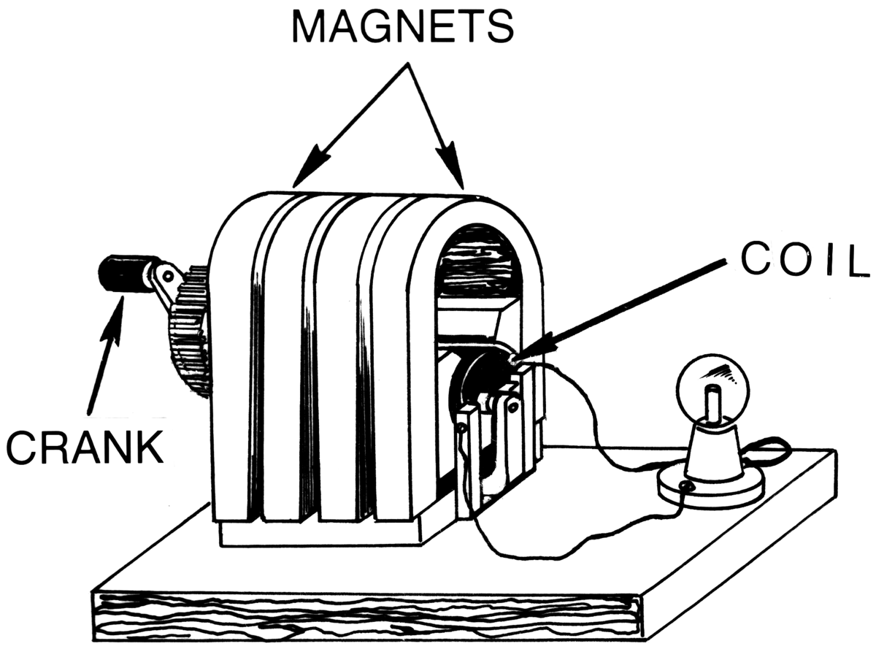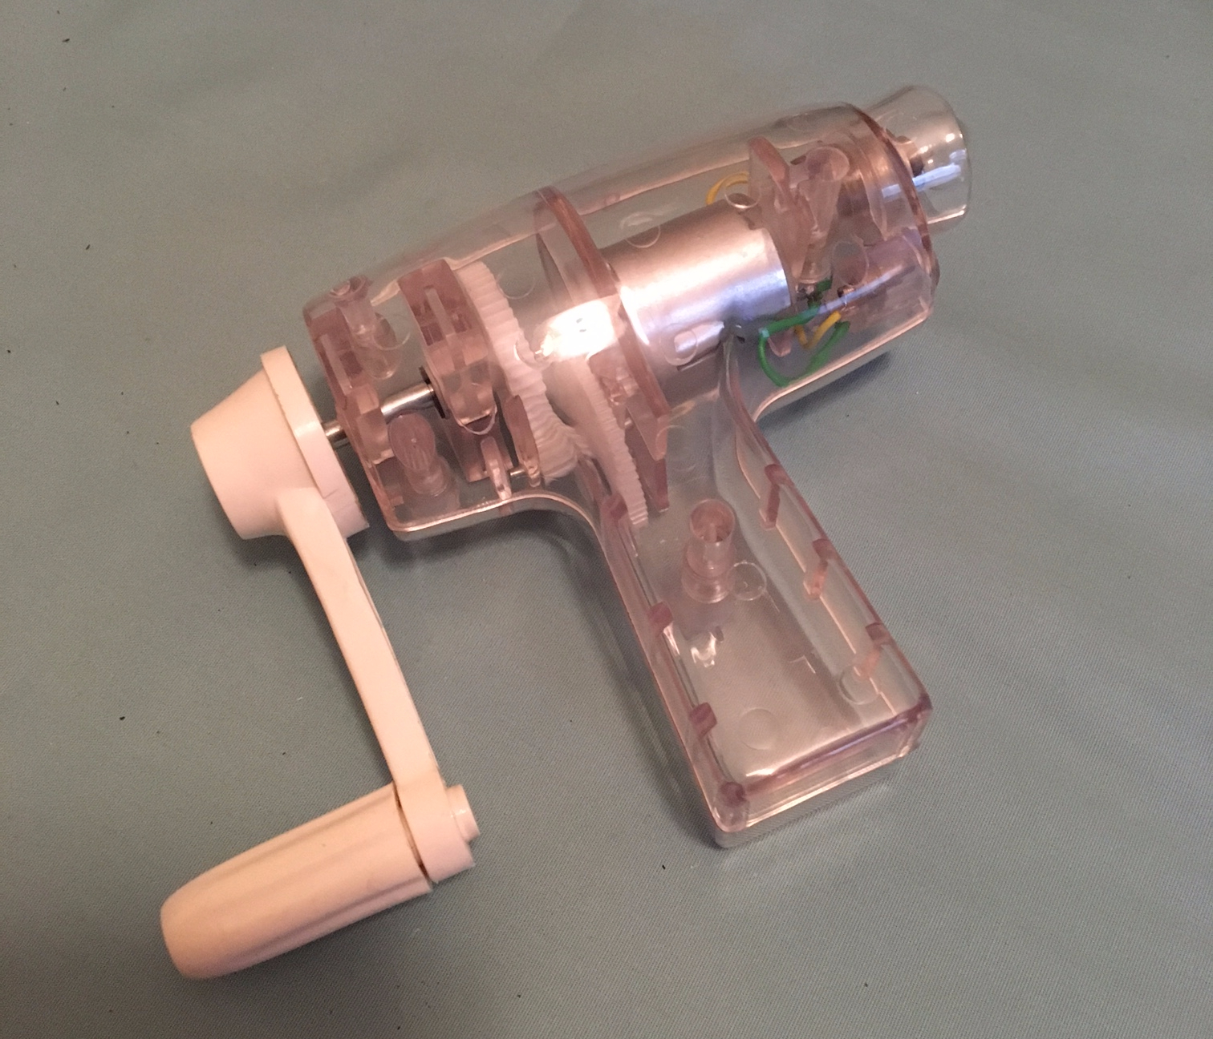

What happens when you turn the handle fast or slow?

What happens if you turn the handle in reverse?

